2024-25 Grand Rapids Community College
Women’s Basketball Roster

NO | NAME | POS | HT | YR | HOMETOWN/HIGH SCHOOL
2 | Tia Richard | G | 5-6 | SO | Donaldsonville, LA / Donaldsonville (’22)
3 | Ava Schultz | F | 5-11 | SO | Wolverine / Gaylord St. Mary (’23)
10 | La’Anna Griffin | F | 6-0 | FR. | Wyoming / Wyoming (’24)
12 | Olivia McKellar | G | 5-8 | RS FR | Grandville / Grandville (’23)
15 | Sophia Modderman | F | 5-11 | SO | Grand Rapids / Kenowa Hills (’23)
20 | Anna Tubbergen | G | 5-7 | SO | Grand Rapids / NorthPointe Christian (’23)
21 | Averi Peot | F | 5-10 | FR | Sparta / Sparta (’24)
22 | Katelyn VanAtter | G | 5-11 | FR | Allegan / Allegan (’24)
23 | Tianna Daye | G | 5-6 | RS FR | Kentwood / East Kentwood (’23)
30 | Tatyana Hardiman | F | 5-8 | FR | Wyoming / Wyoming (’24)
RS | Angelia Duch | C | 6-1 | FR | Allendale / Jenison (’24)
RS | Wren Nelson | C | 6-3 | FR | Scottville / Mason County Central (’24)

Head Coach: Dave Glazier (9th year)
Assistant Coaches: Mike Janikowski, Danny Robinson
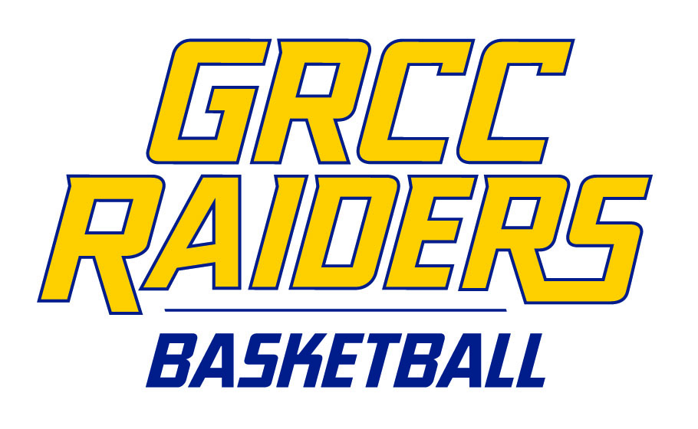
Statistician: Justin Studnicky
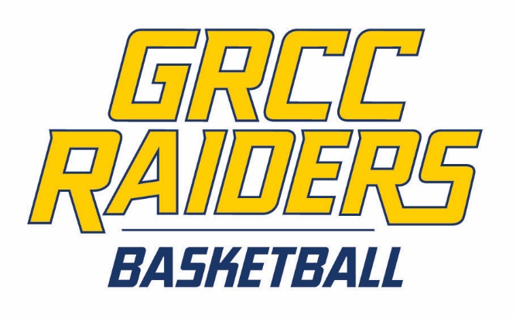
Sports Information Director: Ben Brown
Athletic Trainer: Mackenzie Ondersma
Athletic Director: Lauren Ferullo

